10. Y Carriage Assembly

Vitamins
14 M3 cap screw x 16mm  2 M3 cap screw x 20mm  1 Dibond sheet 216mm x 216mm x 3mm  3 LM8UU bearings | 16 Nyloc nut M3  16 Washer M3 x 7mm x 0.5mm  3 Zip-tie 100mm min length

Printed parts
1 ribbon_clamp_26_33.stl  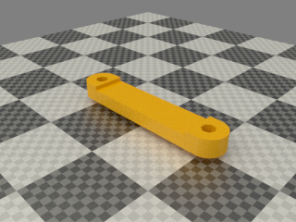 | 1 ribbon_clamp_26_33N.stl  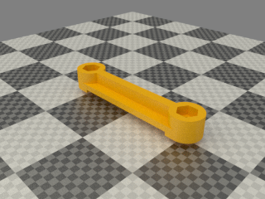 | 3 y_bearing_mount.stl  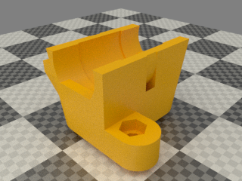
1 y_belt_anchor.stl  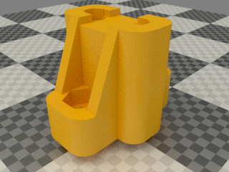 | 1 y_belt_anchor_toothed.stl  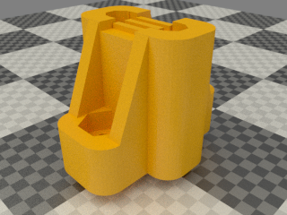
1 y_belt_clip.stl  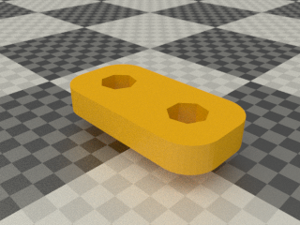 | 1 y_belt_clip_toothed.stl  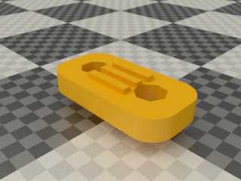

Assembly
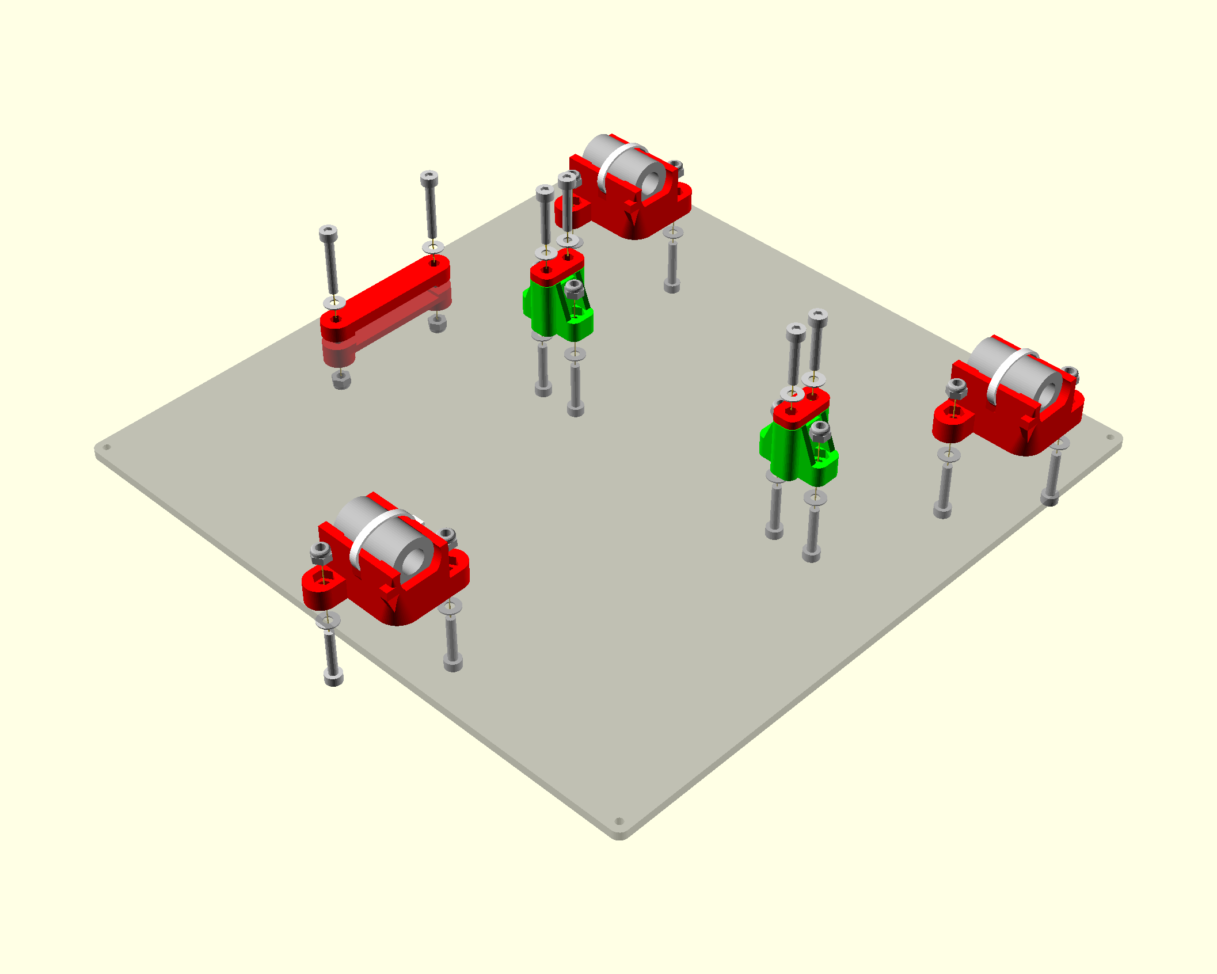
This view is from the bottom of the bed which is the matt side of the Dibond. Except for the cable clamps, the nuts go on the bottom and the screw heads and washers on top . The cable clamps have the heads on the bottom to avoid a clash with the Y idler.
- Insert M3 nyloc nuts into all of the nut traps, including those that go all the way up to the top of the belt anchors. A long M3 screw can be used to pull them up to the top.
- Tie the bushingss into the holders with the zip ties, and screw the holders to the carriage using M3 x 16mm screws and washers. Note that one side of the bearing holders has a tab to trigger the limit switch and that must face forwards (that is, away from the ribbon clamp).
TIP: use the square to help make the rod and holders parallel to the edge
- Align the two bearings on the left (right on the picture) by inserting a rod and lining up the tabs with the edge of the board before tightening the screws. Leave the third bearing loose.
- Fit the belt clamps loosely to retain the nuts using M3 x 16mm screws and washers, then fit the anchors to the carriage using M3 x 16mm screw and washers. Note that the anchor with the teeth goes at the back (nearest to the ribbon clamp) and the belt clamp with the teeth at the front.

- Fit two wide ribbon clamps to the holes at the back of the board using M3 x 20mm screws and washers.

